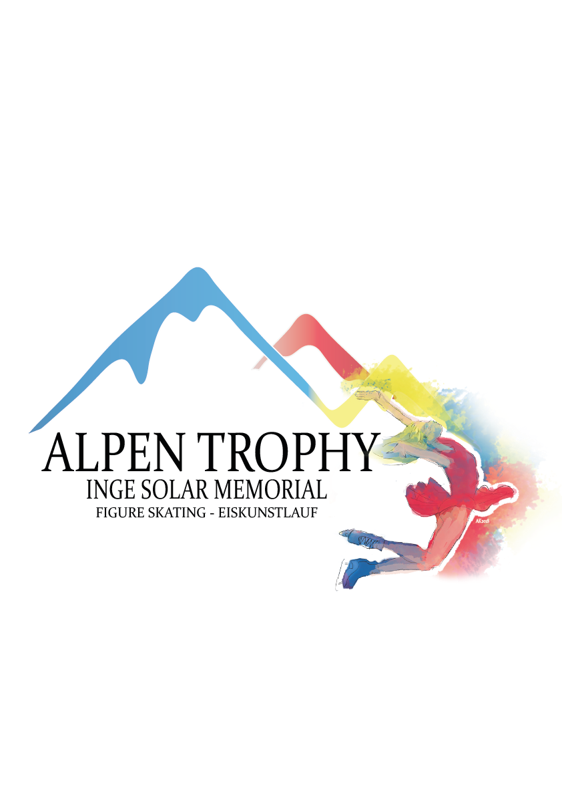

**INGE SOLAR MEMORIAL – ALPEN TROPHY 2018**

**INNSBRUCK, AUSTRIA**

**ANNOUNCEMENT**

**ALPEN TROPHY**

**1. GENERAL**

The “**Inge Solar Memorial - Alpen Trophy 2018**” will be an international competition in Figure Skating and is a ISU listed international competitions in the categories basic Novice, advanced Novice and Junior categories.

The **Inge Solar Memorial - Alpen Trophy 2018** will be conducted in accordance with the ISU Constitution and General Regulations 2018, the Special Regulations and Technical Rules Single & Pair Skating and Ice Dance 2018 as well as all pertinent ISU Communications.

Participation in the Inge Solar Memorial - Alpen Trophy 2018 is open to all competitors who belong to an ISU Member, Rule 109, paragraph 1, and qualify with regard to eligibility, according to Rule 102, provided their ages fall within the limits specified in Rule 108, paragraph 3. a) and they meet the participation, citizenship and residency requirements in Rule 109, paragraphs 1 through 5 and ISU Communication 2030.

Passports of the skaters, as well as the ISU Clearance Certificate, if applicable, must be presented at the accreditation.

The prizes consist of the “Inge Solar Trophy 2018. The winners of the Pairs and Ice Dance category as well as the winners of the Single events in all categories will receive the “**Alpen Trophy**” and medals.

**2. TECHNICAL DATA**

ISU Member: Skate Austria, Österreichischer Eiskunstlaufverband

Place: Olympiaworld Innsbruck

A skating complex with two indoor ice-rinks, air conditioned and heated with the ice surface of 60m x 30m each; the rinks are next to each other.

**GENERAL**

The senior competitions in all disciplines are held as a part of the ISU Challenger Series. Therefore an individual announcement is available. Senior skaters cannot be entered in the Alpen Trophy and have to be entered according to the announcement of the ISU Challenger Series Inge-Solar Memorial – Alpen Trophy 2018.

**SINGLE SKATING**

**Chicks Girls and Boys**

(skaters who have not reached the age of 8 before July 1st, 2018)

Free skating: 2 min (+/- 10 sec)

- 4 jump elements (maximum 2 of them as a jump combination or sequence.

All Jump combinations may only consist 2 double jumps. No triple jumps are allowed.

Each jump may only be repeated twice in a program.

- 2 different spins

- 1 step sequence, which must at least utilize 1/2 of the ice surface.

The Program Components are only judged in

• Skating Skills

• Performance

The Factor of the Program Components is 2.5.

Levels explanations:

In all elements which, are subject to Levels, only features up to Level 2 will be counted. Any additional features will not count for Level requirements and will be ignored by the Technical

Panel.

**Cubs Girls and Boys**

(skaters who have reached the age of 8 but not 10 before July 1st, 2018)

Free skating: 2 min (+/- 10 sec)

- 4 jump elements (maximum 2 of them as a jump combination or sequence.

All jump combinations may only consist of 2 double jumps. No triple jumps are allowed.

Each jump may only be repeated twice in a program.

- 2 different spins

- 1 step sequence, which must at least utilize 1/2 of the ice surface.

The Program Components are only judged in

• Skating Skills

• Performance

The Factor of the Program Components is 2.5.

Levels explanations:

In all elements which, are subject to Levels, only features up to Level 2 will be counted. Any additional features will not count for Level requirements and will be ignored by the Technical

Panel.

**Basic Novice Girls and Boys**

Age and requirements according to the ISU Technical Rules Single & Pair Skating 2018, ISU Communication 2172 and all respective ISU Communications.

**Advanced Novice Girls and Boys**

Age and requirements according to the ISU Technical Rules Single & Pair Skating 2018, ISU

Communication 2172 and all respective ISU Communications.

**Junior Ladies and Men**

Short Program: In accordance with theISU Technical Rules Single and Pair Skating 2018, Rule 611 and the respective ISU Communications.

Free Skating: In accordance with ISU Technical Rules Single and Pair Skating 2018, Rule 612 and the respective ISU Communications. Special attention should be paid to the “well balanced program” and the element value.

**PAIR SKATING**

**Junior** **Pairs**

Short Program: In accordance with the ISU Technical Rules Single and Pair Skating 2018, Rule 620 and the respective ISU Communications.

Free Skating: In accordance with ISU Technical Rules Single and Pair Skating 2018, Rule 621 and the respective ISU Communications. Special attention should be paid to the “well balanced program” and the element value.

**ICE DANCE**

**Junior Ice Dance**

Rhythm Dance: In accordance with ISU Technical Rules Ice Dance 2018, Rule 709.

Rhythms, required elements and guidelines are those listed in ISU Communications 2148, 2164 and subsequent updates.

Free Dance: In accordance with ISU Technical Rules Ice Dance 2018, Rule 710. The required elements to be skated are those listed in ISU Communication 2148, 2164 and subsequent updates.

**3. ENTRIES of COMPETITORS**

Each ISU Member has the right to nominate up to three (3) competitors/couples for each event in the “**Inge Solar Memorial - Alpen Trophy 2018**”. In case of too many entries, the Organizer may limit (reduce) the final entries.

There will be a list of alternate skaters/couples, if more entry requests arrive than the limited number as to paragraph a) below.

a) There will, in principle, be a total of 30 competitors in each individual discipline, 16 Pairs and 16 Ice Dance couples.

With the entry forms, the “Program Content Sheet” must be returned to the Organizing Committee. It is mandatory that the Program Content Sheet be completed precisely by each skater/couple in English using the proper terminology.

**4. ENTRIES of JUDGES**

Each ISU Member has the right to enter one judge with the qualification “ISU or International”. If an ISU Member has entries in three or more disciplines, this Member has the right to enter a second judge, who has to have the qualification “ISU or International for Figure Skating” **AND** also “ISU or International” for Ice Dance”.

**Should there be too many judges nominated for participation, the organizer reserves the right to draw for the composition of panels beforehand and inform those judges who are not drawn for service. Such a draw will be made in the presence of international Judges.**

**5. ENTRIES of TEAM DELEGATION**

Official entries of Team Leaders, Team Officials, Coaches/Choreographers, Team Medical staff etc. must be made together with the entries for Competitors and Judges. The names of such Team Officials must be sent together with the entries of competitors.

**6. ENTRY DEADLINES**

Preliminary Entries:

**October 1, 2018.**

Entries for Competitors, Judges and Delegation + Hotel and Travel Details

**October 12, 2018 (20:00 local time)**

**To:**

[**karin.hoeller@chello.at**](mailto:karin.hoeller@chello.at)and[**info@eislaufschule.at**](mailto:info@eislaufschule.at)

**Please not that when sending your flight details you will be automatically entered into the shuttle plan (50,00 Euros per person one way).**

Travel changes after Monday, October 19th, cannot be taken into account.

If you do not require a pick-up service by bus, please do not send your travel details.

All other forms must also reach the **Organizing Committee, the Union Eislaufschule Innsbruck** by **October 12, 2018.**

An overview of all forms is provided at the end of this announcement. Please find all forms in electronic version on the following website:

<https://alpentrophy.jimdosite.com>

**7. MUSIC**

All Competitors shall furnish competition music of excellent quality on CD or in any other approved format, in accordance with Rule 343, paragraph 1. A list of titles, composers and orchestras of the music to be used for the Short Program and Free Skating Program for Single and Pairs, for the Rhythm and Free Dance Program for Ice Dance must be listed for each Competitor on the official Music Selection Form and attached to the official Entry Form for Competitors.

In accordance with Rule 343, paragraph 1, all covers/discs must show the Competition event, Competitor’s name, the Nation and the exact running time of the music (not skating time) including any starting signal and must be submitted at the time of registration. Each program (short program, free skating, rhythm dance, free dance) must be recorded on a separate disc. In addition, competitors/couples must provide a back-up drive for each program.

If music information is not complete and/or the music is not provided, accreditation will not be given.

**8. EXPENSES PROVIDED**

The organizer will provide accommodation and meals for all Referees and Judges drawn for the panel, Technical Controllers, Technical Specialists, Data and Replay Operators who are participating in the “**Inge Solar Memorial - Alpen Trophy 2018**”:

from Sunday, November 11, 2018 starting with dinner

to Sunday, November 18, 2018, ending with breakfast.

Judges who are entered only for Novice and Junior:

from Sunday, November 11, 2018 starting with dinner

to Wednesday, November 14, 2018 ending with breakfast.

Judges who are entered only for Ice Dance or Pairs

from Wednesday, November 14, 2018 beginning with dinner

to Sunday, November 18, 2018 ending with breakfast.

Judges who are entered for Chicks and Cubs only:

from Saturday, November 17, 2018 starting with dinner

to Sunday, November 18, 2018 ending with dinner.

**Competitors and all other Team members must cover their own living expenses.**

Travel expenses will be paid **only** to the Referees, the Technical Specialists, Technical Controllers, Data and Replay Operators based on economy airfare.

**9. INDIVIDUAL RESULTS**

**Judging and calculations will be done according to ISU Special Regulations Single and Pair Skating and Ice Dance 2018, Rule 352 and 353**

The three best-placed skaters/couples in each event will be announced and honoured at the official Victory Ceremony. The national anthem of the winner will be played and the flag of the medal winners hoisted.

**10. LIABILITY**

In accordance with Rule 119, it is the sole responsibility of each Member participating in the “**Inge Solar Memorial - Alpen Trophy 2018**”, to provide medical and accident insurance for their athletes, officials and all other members of the Member’s team. Such insurance must assure full medical attendance and also the return to the home country by air transport or by other expeditious means of the ill or injured person.

The Organizer assumes no responsibility for or liability with respect to bodily or personal injury or property damage incurred in connection incurred by Competitors and Officials, except in cases of gross negligence or intent.

**11. REGISTRATION**

The official accreditation for teams is planned at the **Olympiaworld Innsbruck.**

Accreditation as a Team Member will be given to all entered Judges, Competitors and one Team Leader per participating team, one Coach per Competitor, a maximum of two Team Officials of ISU Members (including the Member President), provided that they are Council Members, Technical Committee Members or Members of the Head Office of their Federation and a maximum of two medical persons. Accreditation will only be granted to persons in those various functions if officially entered and named through their ISU Member.

Accreditation will be given to appointed Event Officials and Guests. Chaperons will not receive accreditation. They a valid ticket, which will be available at the accreditation desk.

**12. ENTRY FEE**

The entry fee for skaters/couples will be as follows:

**70.00 € per single skater**

**90.00 € per pair or ice dance couple**

**The entry fee will not be refunded in case of withdrawals for any reason, except when the organizer has to reduce the entries.**

Entry fees are required at time of final entries (not later than October 12, 2018).

Bank: Bank für Tirol und Vorarlberg

Account owner: Union Eislaufschule Innsbruck, Wilhelm Greil Straße 14, 6020 Innsbruck

BIC: BTVAAT22

IBAN: AT83 1600 0001 1611 0377

**13. ACCOMMODATION**

There is no official hotel recommended.

**Teams can contact**

Innsbruck Tourismus

Burggraben 3, 6021 Innsbruck

Email: [office@innsbruck.info](mailto:office@innsbruck.info)

Phone: +4351259850

(please send your booking request as a copy to the Organizing committee [info@eislaufschule.at](mailto:info@eislaufschule.at))

**14. PRACTICE**

There is official practice only for junior categories and will start on **Monday, November 12, 2018**.

A detailed schedule will be posted well ahead and will also be handed out at the time of registration.

**15. VARIOUS**

The nearest airport is Innsbruck. There are direct public busses directly from the airport to the Olympiaworld Innsbruck and most of the hotels.

Please note:

If you plan to travel by plane, please use the airport of Innsbruck. There will be no shuttle or pick-up service from other Airports.

All Events will be broadcasted on [www.livestream.com/sportevents](http://www.livestream.com/sportevents). All participants confirm that their programs will be broadcasted worldwide and be available online also after the competition has finished.

**16. ALPEN TROPHY**

The **ALPEN TROPHY** will be awarded to the best-placed skaters of all disciplines in all categories except seniors.

**17. INFORMATION**

Please address all requests to:

Union Eislaufschule Innsbruck

c/o CEO Georg Ganner

Wilhelm Greil Straße 14, 6020 Innsbruck,

Phone: +43 676 5343759

Email: [info@eislaufschule.at](mailto:info@eislaufschule.at)

**18. PROVISIONAL EVENT SCHEDULE (subject to changes)**



**19. Competition Entry Forms Overview**

Form Deadline

Preliminary Entry Form for Inge Solar Memorial – Alpen Trophy October 1, 2018

Entry Form Competitors, Judges, Delegation October 12th, 2018

Team Travel Form October 12th, 2018

VISA Request Form October 12th, 2018

Press Information October 12th, 2018

Competition Music Information October 12th, 2018

Ice Dance Music Information October 12th, 2018

Planned Program Content October 12th, 2018